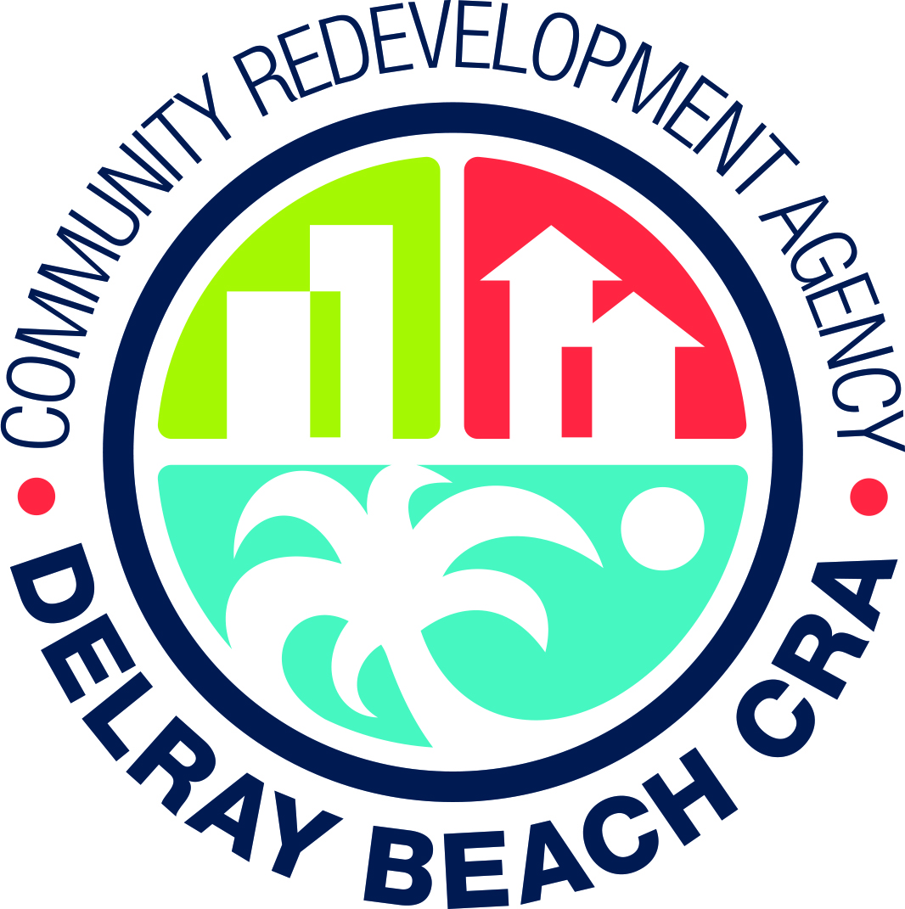

PUBLIC NOTICE
NOTICE OF INTENT TO ACCEPT PROPOSAL
IN THE CITY OF DELRAY BEACH, FLORIDA

Pursuant to Section 163.380, Florida Statutes, notice is hereby given that the Community Redevelopment Agency of the City of Delray Beach intends to consider and may accept the offer from the Habitat for Humanity of South Palm Beach County, Inc. to purchase CRA-owned properties for the development of four (4) affordable single-family housing units, subject to the Board’s receipt and review of any further proposals from the public as a result of its issuance of this Notice of Intent to purchase such real property. The CRA-owned property is located at 238 SW 14th Ave, Delray Beach, Florida, 33444. The legal descriptions of the property is as follows:

238 SW 14th Ave, Delray Beach, FL 33444
Property Control Number: 12-43-46-17-19-003-0101
Legal Description: ATLANTIC PARK GARDENS PRIEST ADD N 55 FT OF S 117 FT OF E ½ OF BLK 3, , according to the Plat thereof, as recorded in Plat Book 27249, Page 499 of the Public Records of Palm Beach County, Florida.

Additional information may be obtained by contacting Krista Walker, CRA Contract Manager, 20 N. Swinton Avenue, Delray Beach, Florida 33444, or walkerk@mydelraybeach.com.

All proposals must be submitted by those interested within thirty (30) days after the date of this public notice to: Delray Beach Community Redevelopment Agency, 20 N. Swinton Avenue, Delray Beach, FL 33444. The CRA Board reserves the right to accept or reject any proposal and to negotiate an agreement with any selected proposers.

Shelly Petrolia, Chair
Jeff Costello, Secretary
Community Redevelopment Agency
Delray Beach, FL
Date: June 18, 2018
Published: June 18, 2018

